Vision and Scope Document

for

Hotel Management System

**Version 1.0 approved**

**Prepared by ÂN PHAN, HƯNG THỊNH, TRUNG TRẦN, ĐỨC CƯỜNG**

**Process HMS**

**September 15, 2021**

**Table of Contents**

Table of Contents ii

Revision History ii

1. Business Requirements 1

1.1. Background 1

1.2. Business Opportunity 1

1.3. Business Objectives 1

1.4. Success Metrics 1

1.5. Vision Statement 1

1.6. Business Risks 1

1.7. Business Assumptions and Dependencies 2

2. Scope and Limitations 2

2.1. Major Features 2

2.2. Scope of Initial Release 2

2.3. Scope of Subsequent Releases 2

2.4. Limitations and Exclusions 2

3. Business Context 2

3.1. Stakeholder Profiles 2

3.2. Project Priorities 3

3.3. Deployment Considerations 4

**Revision History**

| **Name** | **Date** | **Reason For Changes** | **Version** |
| --- | --- | --- | --- |
| Đức Cường | 15/9/2021 | Background and Business Opportunity, edit document | 1.0 |
| Hiếu Trung | 16/09/2021 | Business objective, Success metrics, Vision statement, Business Risks, Business Assumptions and Dependencies | 1.1 |
| Đức Cường | 20/9/2021 | Scope of Initial and Subsequent Releases, Limitations and Exclusions | 1.2 |
| Hưng Thịnh, Hiếu Trung | 10/10/2021 | Major change to fit desktop application | 1.3 |

# Business Requirements

## Background

According to statistics in Ho Chi Minh City, the demand for hotel use is equally high at all times because it is a big city so if a hotel uses traditional methods such as manual recording, billing, .. When checking in or checking out, it is very time consuming, easy to make mistakes for staff and damage to hotel and customers. In addition, customers who come to the place to rent the room are full, and have to spend more time looking for another hotel. Moreover, some normal hotels are crowded and some good service hotels are empty due to not having a good location. Managing hotel staff, unprinted rooms and managing customers is hard work, so we developed the Hotel Management application to solve this problem and above all we want more functions. help hotel owners increase their ability to manage and run their organization and business.

## Business Opportunity

Nowadays most hotels use this system instead of traditionway. Because It helps this hotel work more efficiently, earn high profits, and reduce the waste of time of customers and employees. Besides, it is easy to use, to update, store data and report the necessary information.

## Business Objectives

BO-1: 50% Reduce time when check-in and check-out.

BO-2: 30% Reduce time to change the price and entity of rooms, services,...

BO-3: 90% Increase the safety of the data when using the system.

## Success Metrics

SM-1: More than 90% of hotels use this system instead of the traditional way.

SM-2: This system can be updated like a mobile app when your hotel needs an online booking system.

## Vision Statement

For hotel staff who work under hotel <<Hotel Name>> at <<Hotel Address>> , the Hotel Management System is a desktop-based application that will accept individual check-ins or group check-ins, check-out, manage rooms, manage employees, and manage services in the hotel. Unlike the current manual process, hotel staff who use the Hotel Management System will not have to write down information or work based on paper with slow and complicated stages that the system will do instead to save time and increase the performance of hotel staff working.

## Business Risks

RI-1: Periodic reports can be incorrect and it is necessary for the system to have an employee check the payment at the end of day. (Probability = 0.6)

RI-2: Sometimes the billing process of check in or check out function will delay because of third party connection. (Probability = 0.1)

RI-3: Can be a waste of time to load data and get bugs. (Probability = 0.2)

## Business Assumptions and Dependencies

AS-1: Using Windows OS with .NET 5 framework.

AS-2: Advertising notification will show in smart ways.

DE-1: Only payment by visa mastercard.

# Scope and Limitations

## Major Features

FE-1: Check in and Check out.

FE-2: Create, view, modify, delete, and archive service.

FE-3: Create, view, modify, delete, and archive a room type.

FE-4: Create, view, modify, delete, and archive customer information.

FE-5: View, search available Room and Service.

FE-6: Authenticate user.

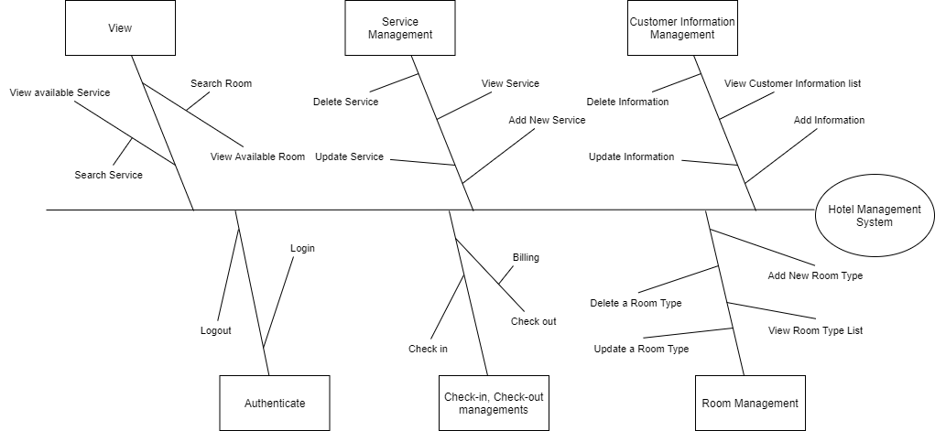

## Scope of Initial and Subsequent Releases.

| **Feature** | **Release 1** | **Release 2** | **Release 3** |
| --- | --- | --- | --- |
| FE-1: Authenticate | Not implemented | Fully Implemented |  |
| FE-2: Check in and Check out | Not implemented | Accept payment in cash or credit card payments, or will be included in the total bill. | Fully implemented |
| FE-3: Create, view, modify, delete customer for receptionist | Not implemented | Fully implemented | . |
| FE-4: Create, view, modify, delete service for manager | Create and view service information | Modify and delete room information with updating available room to receptionist view | Fully implemented |
| FE-5: Create, view, modify, delete room for manager | Create and view room information | Modify and delete service information with updating available service to receptionist view | Fully implemented |
| FE-6: View, search available Service and Room for Receptionist | Not implemented | Fully implemented |  |
| FE-7, System access | Server-Client | Window and Mac Os |  |

## Limitations and Exclusions

LI-1: Some of the dishes available on the Hotel's Food and Beverage menu will not be suitable for delivery, so customers are advised to choose products that are still in stock.

LI-2: The system shall only be used for <<Hotel Name>> at <<Hotel Address>>

# Business Context

## Stakeholder Profiles

| ***Stakeholder*** | ***Major Value*** | ***Attitudes*** | ***Major Interests*** | ***Constraints*** |
| --- | --- | --- | --- | --- |
| Hotel Staff | Manage room, booking and services |  | Manage and handle request from user | Internet access is needed |
| Customer | Use the system to booking or booking through staff |  | Simplicity of use | Internet access is needed, pay money for booking. |
| Developer Team | Ensure the system matches with business requirements, user requirements and functional requirements. |  | Clear code, SRS-based request response, UI/UX design satisfying user experience | Internet access is needed. |
| Internet Banking Department | No benefit; third party for payment. |  | Minimal changes in current payroll applications | Internet access is needed and staff must request customer for payment first |
| Marketing Team | Increased sales; marketing exposure to generate new customers |  | Use popular methods and platforms to promote the app widely | Internet access is needed, weekly report. |
| Testing Manager | Find error, and ensure the performance of the production |  | Check for errors on high-risk modules, report bugs and provide solutions | Internet access is needed, checking everytime developer make change or commit, report back if there is a problem |

## Project Priorities

| ***Dimension*** | ***Driver (state objective)*** | ***Constraint (state limits)*** | ***Degree of Freedom (state allowable range)*** |
| --- | --- | --- | --- |
| *Schedule* | *release 1.0 to be available by 10/1, release 1.1 by 12/1* |  |  |
| *Features* |  |  | *70-80% of high priority features must be included in release 1.0* |
| *Quality* |  |  | *90-95% of user acceptance tests must pass for release 1.0, 95-98% for release 2* |
| *Staff* |  | *maximum team size is 1 PM, 1 BA, 6 developers + 3 testers* |  |
| *Cost* |  |  | *budget overrun up to 15% acceptable without sponsor review* |

## Deployment Considerations

The software application will be a desktop application and upgraded to the latest version. App will have to be deployed for the Windows OS environment. The application must be registered with any-third party services like credit card payment with internet access. Users need LAN connection with the server placed in the hotel to use the system, and only connect within the hotel. any change will be in place of the third release.